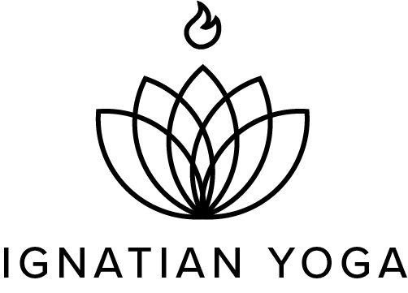
Digital Media Specialist Job Description

We are looking for a qualified Digital Media Specialist to join our team and lead our digital media and marketing efforts. This includes managing, implementing, and promoting the Ignatian Yoga digital media strategy and online presence. We are looking for a self-starter who requires minor oversight. 8-10 hours per week.

Duties and Responsibilities:
Email Communications
- Develop email newsletter strategy to continually improve current monthly newsletter
- Format and edit email marketing campaigns for retreats, programs, and fundraising campaigns
Social Media
- Maintain and build social media presence
- Use social media analytics to drive the development of a comprehensive and effective social media strategy that builds community and engagement
- Design and maintain consistent social media content (Facebook, Instagram, YouTube)
Digital analytics
- Monitor and evaluate ongoing analytics in line with best practices including social media, email, and website
Website
- Maintain and update content for the Ignatian Yoga website, including blog posts, media clips, program statistics, and campaign and event landing pages
- Envision and present ways to improve the Ignatian Yoga website, especially in terms of SEO
Miscellaneous Tasks
- Compile a monthly report detailing email, social media, and web analytics. Present findings, as well as an action plan for the following month.
- Provide technical support for Zoom programs and the online Teacher Formation Program

Qualifications
- Familiarity with Yoga and/or Ignatian spirituality
- Demonstrated strong time management skills
- Proficient in Adobe products
- Spanish language preferred
- Exceptional writing, collaboration, and communication skills
- Background and experience in:
  - Marketing, communications, digital media, or related field
  - Social media (Facebook, Instagram, Twitter)
  - Graphic design and video editing
  - Website management and email marketing platforms (Mailchimp and Wordpress)

To apply please send a cover letter, resume, and any samples of your work (social media posts, graphic design, website, videos, etc.) to bobby@ignatianyoga.com.

